9.78: Quantitatively, from Table (9.2), Object A has the smallest moment of inertia because, of the three objects, its mass is the most concentrated near its axis. b) Conversely, object B’s mass is concentrated and farthest from its axis. c) Because 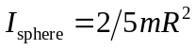, the sphere would replace the disk as having the smallest moment of inertia.

